**<Deepika Vijayasekaran>**

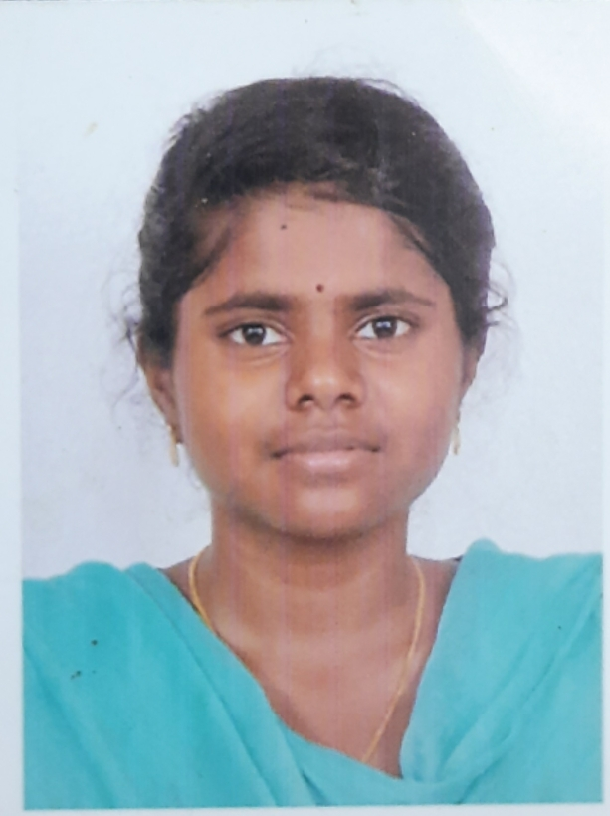

|  |  |
| --- | --- |
| **Title:** | **< Manual Tester, ETL Tester** **>** |
| **Location:** | **< Bangalore>** |
| **Languages:** | **<** Tamil (native),English (fluent) **>** |
| **Email Id:** | **deepika.vijayasekaran@capgemini.com** |
| **Contact Number:** | **8825672880** |

# Experience Summary

< Experience on Web Application functional and System testing. Prepared traceability matrix for test coverage. Good Exposure to Data Warehousing concepts. Hands on experience in writing SQL Queries. Knowledge of various testing techniques like equivalence partitioning, boundary value analysis and Error Guessing. Hands on Experience on different Levels of Testing (Unit Testing, Integration Testing, System Testing and Acceptance Testing). Performed different type testing like Smoke, Regression and Sanity. Excellent debugging skills. Familiar with Functional and Non-functional Testing >

**KEY SKILLS:**

* **Functional:** < A Trusted team player, gentle listener and optimistic mentor with organized approach are the potentials I have portrayed with my work. Excellent communicator who thrives on independently managing deliverables >
* **Technical:** < SQL, Oracle 10g, HP ALM, Rally, Oracle Data Integrator (ODI), Swagger, Soap UI, Sabre, Splunk >

# Experience

< 3.11 years of experience in Software Testing with 3.5 years on manual Testing (Web & mobile) and 6 months on ETL/DWH. Extensive experience in mobile application testing. Good Experience in all the phases of STLC and SDLC. Good domain expertise on DWH concepts>

|  |  |  |
| --- | --- | --- |
| **01** | **Type of Industry:** | **(Restaurant service) (Web/Mobile Application Testing)** |
|  | **Project Description:** | Provides supply chain management solutions to quick service restaurant. The Company offers fulfillment, delivery, inventory management, product sourcing, relationship management, warehousing, training, safety, financial modeling, and reporting services. |
|  | **Role/Title:** | Manual Tester |
|  | **Project Duration:** | Dec 2020-Mar 2021 |
|  | **Responsibilities:** | * Analyze the requirements based on requirements in User Stories * Preparing Test Scenarios for the requirements gathered. * Testing application in Chrome Browser & Android devices * Preparing, executing and documenting the test cases in SharePoint. * Perform functional, System Testing. * Logged the defects and coordinated with the development team to solve the problems using SharePoint. * Attend Scrum meetings / Daily Stand up calls for initiation and creation of Test artefacts * Attending daily, weekly status meetings and sending status reports to client. |
|  | **Operating Systems:** | Windows |
|  | **Special Tools:** | SharePoint |

|  |  |  |
| --- | --- | --- |
| **02** | **Type of Industry:** | **(Travel/Airlines) (Mobile Application Testing)** |
|  | **Project Description:** | Flight ticket checking mobile application automation project. Here we automate some modules like ATO, Gate, EGR and Other Function. By using this app, we can do check-in, Generate Boarding Pass and Bag Tag, Board the passenger and Un-Board. |
|  | **Role/Title:** | Manual Tester |
|  | **Project Duration:** | October 2019-July 2020 |
|  | **Responsibilities:** | * Reviewed Business requirements, IT Design documents and prepared Test Plans which involved various Test Cases for all assigned module/projects; Review Test Requirements, Creating Test Plans and Test Strategy documents. * Prepared Test scenarios, Test cases and executed the same. * Developed several re-usable functions to handle common functionalities. * Used Rally to store all testing results, metrics, created Test Cases, and Reporting. * Developed a Defects Tracking Log for the SharePoint Site to track defects while testing. * Interacted closely with developers regarding defects, participated in tracking, reviewing and analyzing bugs. * Extensively performed Manual Testing process to ensure the quality of the software. |
|  | **Operating Systems:** | Windows |
|  | **Special Tools:** | Rally, Sabre, Splunk |

|  |  |  |
| --- | --- | --- |
| 03 | Type of Industry | **(Health Insurance)** |
|  | **Project Description:** | The health insurance marketplace in the U.S. state of California established under the federal Patient Protection and Affordable Care Act. |
|  | **Role/Title:** | ETL Tester |
|  | **Project Duration:** | April 2019 – Sep 2019 |
|  | **Responsibilities:** | * Involved in functional study of the application * Involved in writing Test Plan * Running the Jobs/Workflow for ETL process * Prepared and ran SQL queries to verify Dimensional and Fact tables * Verifying the data in target database after ETL process * Performed column data mapping between source & target database. * Prepared test data for testing * Verifying the data which is loaded into target database * Reporting daily testing status report * Developed, Reviewed & Executed Test Scripts and Designed test data * Defect Analyzing and Reporting in Rally |
|  | **Operating Systems:** | Windows |
|  | **Software / Languages:** | SQL, Oracle 10g, Oracle Sql developer |
|  | **Special Tools:** | Oracle Data Integrator (ODI), Autosys |

|  |  |  |
| --- | --- | --- |
| 04 | Type of Industry | **(Airlines)** |
|  | **Project Description:** | Web Application for internal communication purpose. The automation framework of this application is built using Selenium tool with Java platform. The data used in application is created using the tool Swagger that runs the web services. |
|  | **Role/Title:** | Manual Tester |
|  | **Project Duration:** | November 2016 – March 2019 |
|  | **Responsibilities:** | * Participated in Requirement Specification Meetings to understand the application’s functional requirements to initialize the test scenarios and test flows * Identification of test data for performing Integration Testing. * Created test scenarios, test conditions and expected results and testcases. * Analyzed the Defects and raised it in HP-ALM to get better build for the end Users. * Managing knowledge sharing to the team after identifying critical bug. * Client Interaction for K.T Sessions and Reverse K.T Sessions and BA activities. * Assigning and tracking of work to the team members. * Involved in preparing daily status report and Weekly status execution tracker. * Handling daily status calls between onshore and offshore and pro-actively. * Reviewed and consolidated daily status reports of every tester in absence of lead. * Worked with the onshore team for maintenance of the test. |
|  | **Operating Systems:** | Windows |
|  | **Special Tools:** | HP-ALM, Swagger, Soap UI |

# Training, Certifications & Affiliations

* < **ISTQB** - Foundation Level certified with 82.5% in 2018 >

# Published & Presented / Awards

* < “**SPOT**” Award- self Initiative for completing ISTQB >

# Higher Education

* < Kingston Engineering college – Vellore, India >